FITBUDDY-AI FITNESS PLAN GENERATOR USING GEMINI MODELS

PROJECT DESCRIPTION:
FitBuddy is a web-based AI-powered fitness planning application developed using FastAPI and Google Gemini models. The application helps users generate personalized 7-day workout plans based on their fitness goals and preferred workout intensity.
The system collects user information such as name, user ID, age, weight, fitness goal, and workout intensity. Based on the selected goal and intensity, the application generates a structured workout plan using Gemini AI.
The application also provides a nutrition or recovery tip and allows users to submit feedback about their existing workout plan. The feedback is processed by the AI model to generate an updated workout plan.
User information and workout plans are stored using SQLite and SQLAlchemy. Jinja2 templates are used to dynamically display the user input, generated workout plan, nutrition tip, and updated plan.
SCENARIOS:

Scenario 1: Generate Personalized Workout Plan
A user enters their:
- Name
- User ID
- Age
- Weight
- Fitness Goal
- Workout Intensity
The system sends the selected fitness goal and workout intensity to the Gemini AI model and generates a personalized 7-day workout plan.
The generated plan contains:
- Warm-up
- Main workout
- Sets and repetitions
- Rest period
- Cool-down
- Recovery days

Scenario 2: Generate Nutrition / Recovery Tip:
After generating the workout plan, FitBuddy generates a short nutrition or recovery tip based on the user's selected fitness goal.
The tip may include general suggestions related to:
- Hydration
- Balanced meals
- Protein sources
- Recovery
- Healthy food choices

Scenario 3: Update Workout Plan Using Feedback:
Users can provide feedback about their existing workout plan.
For example:
- Add more cardio
- Include more rest days
- Make the workout simpler
- Add flexibility exercises
The system sends the original workout plan, user feedback, fitness goal, and workout intensity to Gemini AI.
The AI then generates a revised 7-day workout plan.

Scenario 4: View All Users:
The application provides an admin-style View All Users page.
The page displays:
- Username
- User ID
- Age
- Weight
- Fitness Goal
- Workout Intensity
- Original Workout Plan
- Updated Workout Plan
- Nutrition Tip
This allows the stored user information and generated plans to be viewed in one place.
TECHNICAL ARCHITECTURE:
FitBuddy follows a modular web application architecture.

Frontend
- HTML
- CSS
- Jinja2 Templates

Backend
- Python
- FastAPI
- Uvicorn

AI Layer
- Google Gemini API
- Gemini Flash model

Database
- SQLite
- SQLAlchemy ORM

Data Validation
- Pydantic

PROJECT STRUCTURE:
fitbuddy project/
│
├── app/
│ ├── ai/
│ ├── database.py
│ ├── gemini_flash_generator.py
│ ├── gemini_generator.py
│ ├── main.py
│ ├── routes.py
│ ├── schemas.py
│ └── updated_plan.py
│
├── static/
│ └── css/
│ └── style.css
│
├── templates/
│ ├── index.html
│ ├── result.html
│ └── all_users.html
│
└── requirements.txt

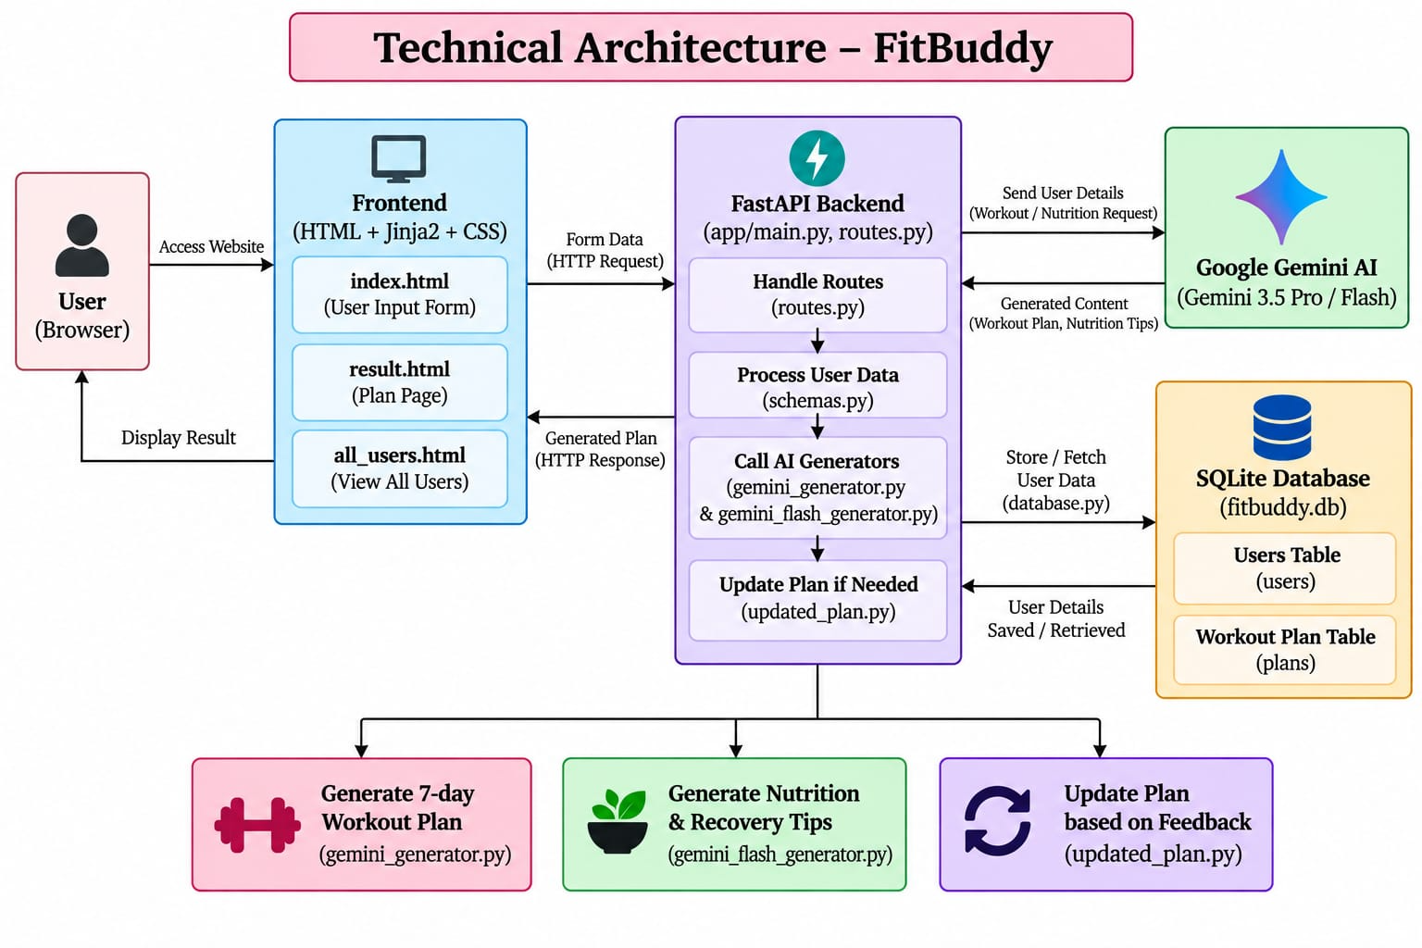

PRE-REQUISITES:
The following knowledge and software are required:
- Python Programming
- FastAPI Framework
- HTML and CSS
- Jinja2 Templates
- Google Gemini API
- SQLAlchemy
- SQLite Database
- Pydantic
- Uvicorn
- Python Virtual Environment
PROJECT WORKFLOW:

Milestone 1 – Project Setup and Architecture
Activity 1.1: Define project requirements
Activity 1.2: Select Gemini AI integration
Activity 1.3: Design application architecture
Activity 1.4: Set up Python virtual environment
Activity 1.5: Install required libraries

Milestone 2 – AI Functionality Development
Activity 2.1: Develop workout plan generation
Activity 2.2: Develop nutrition tip generation
Activity 2.3: Develop feedback-based plan updating

Milestone 3 – Backend Development
Activity 3.1: Create FastAPI application
Activity 3.2: Develop application routes
Activity 3.3: Process user form data
Activity 3.4: Integrate Gemini API
Activity 3.5: Connect database operations

Milestone 4 – Database Development
Activity 4.1: Create SQLite database
Activity 4.2: Create User table
Activity 4.3: Create WorkoutPlan table
Activity 4.4: Store user information
Activity 4.5: Store original and updated workout plans

Milestone 5 – Frontend Development
Activity 5.1: Design user input page
Activity 5.2: Design workout result page
Activity 5.3: Design feedback form
Activity 5.4: Design all users page
Activity 5.5: Apply responsive CSS styling

Milestone 6 – Deployment and Testing
Activity 6.1: Configure environment variables
Activity 6.2: Install project dependencies
Activity 6.3: Start FastAPI server
Activity 6.4: Test application routes
Activity 6.5: Verify AI-generated responses

MILESSTONE 1-PROJECT SETUP AND ARCHITECTURE:
FitBuddy is designed as a modular FastAPI application where the frontend, backend, AI processing, and database layers work together.
The main components are:
- Frontend: HTML, CSS and Jinja2
- Backend: FastAPI
- AI: Google Gemini
- Database: SQLite
- ORM: SQLAlchemy

Activity 1.1 – Project Requirements:
The application is designed to perform the following functions:
- Collect user fitness information
- Generate a 7-day workout plan
- Generate nutrition/recovery advice
- Accept user feedback
- Update the workout plan
- Store user information
- Store workout plans
- Display all users and their plans

Activity 1.2 – AI Model Integration:
The project uses Google's Gemini API for AI-powered content generation.
The application uses the Gemini model specified through the environment variable:
GEMINI_MODEL
The default model used by the project is:
gemini-2.5-flash
The AI is used for:
- Workout plan generation
- Nutrition tip generation
- Workout plan modification

Activity 1.3 – Environment Setup :
Create a virtual environment:
python -m venv venv
Activate it on Windows:
venv\Scripts\activate
Install the required libraries:
pip install -r requirements.txt
The project's requirements.txt contains:
fastapi
uvicorn
jinja2
sqlalchemy
python-multipart
python-dotenv
google-genai

Milestone 2 – AI Functionality Development:
Activity 2.1 – Workout Plan Generation:
Function:
generate_workout_gemini()
File:
gemini_generator.py
This function generates a personalized 7-day workout plan.
The function receives:
goal
intensity
The AI prompt requests the following structure:
Day 1:
Warm-up:
Main Workout:
Sets/Reps:
Rest:
Cool-down:
The same structure continues until Day 7.
The generated plan also includes suitable recovery/rest days.

Code:
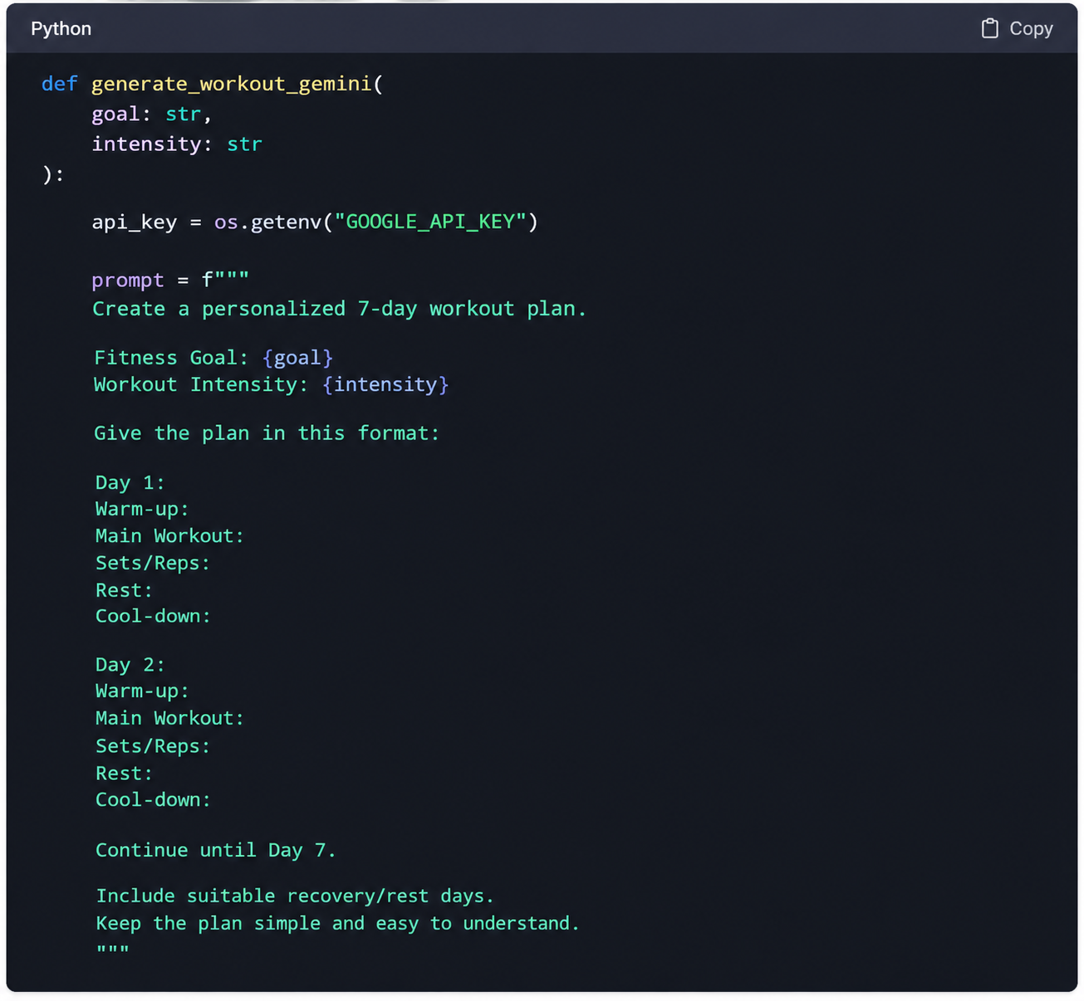

Activity 2.2 – Nutrition Tip Generation:

Function:
generate_nutrition_tip_with_flash()

File:
Gemini_flash_generator.py
This function generates a short nutrition or recovery tip based on the user's fitness goal.

The prompt is:

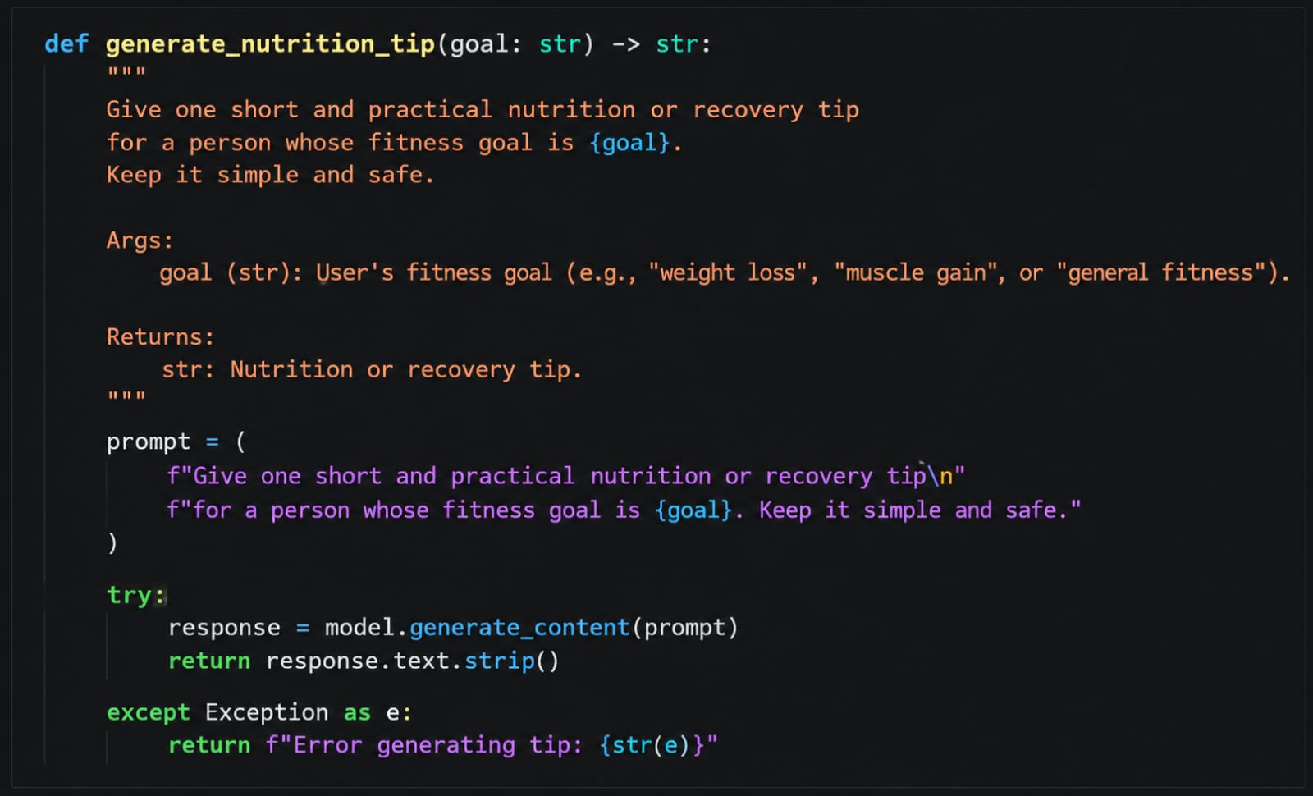
Activity 2.3 – Feedback-Based Plan Updating:
Function:
update_workout_plan()
File:
Updated_plan.py
The original plan is provided to the Gemini model along with the feedback. The AI is instructed to keep the useful parts of the original plan while applying the changes requested by the user. It then generates a revised 7-day workout plan that is simple and easy to understand.
The updated plan is then stored in the SQLite database through the update_plan() function. The application displays both the original workout plan and the updated workout plan on the result page. This makes it easy for the user to compare the changes made based on their feedback.
The feedback process follows these steps:
- The user generates an initial 7-day workout plan.
- The generated plan is displayed on the result page.
- The user enters feedback in the feedback text area.
- The application receives the User ID and feedback.
- The system retrieves the user's existing information from the database.
- The original workout plan is retrieved from the database.
- The original plan, feedback, fitness goal, and workout intensity are sent to the Gemini model.
- Gemini generates a revised 7-day workout plan.
- The updated plan is saved in the database.
- The updated workout plan is displayed to the user.

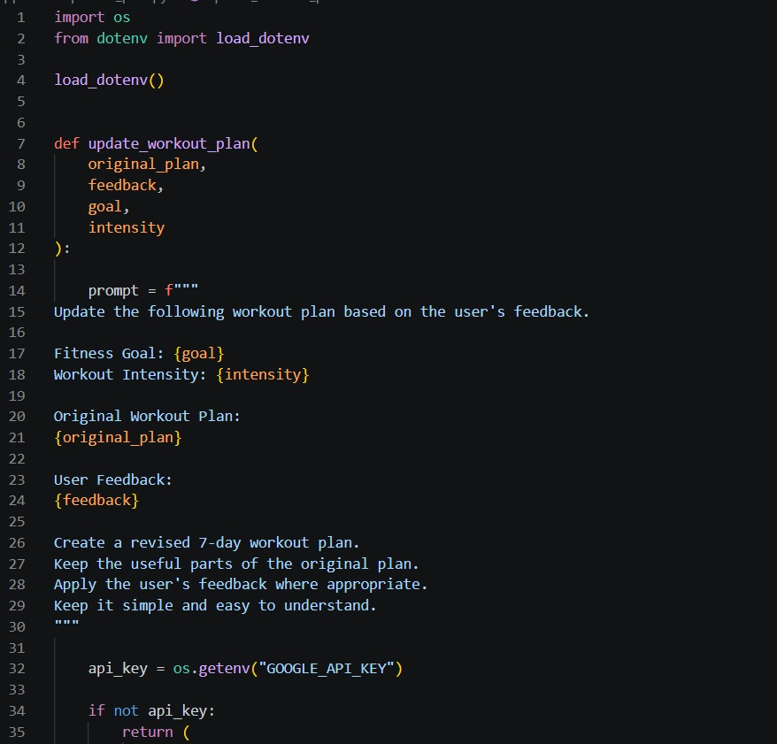
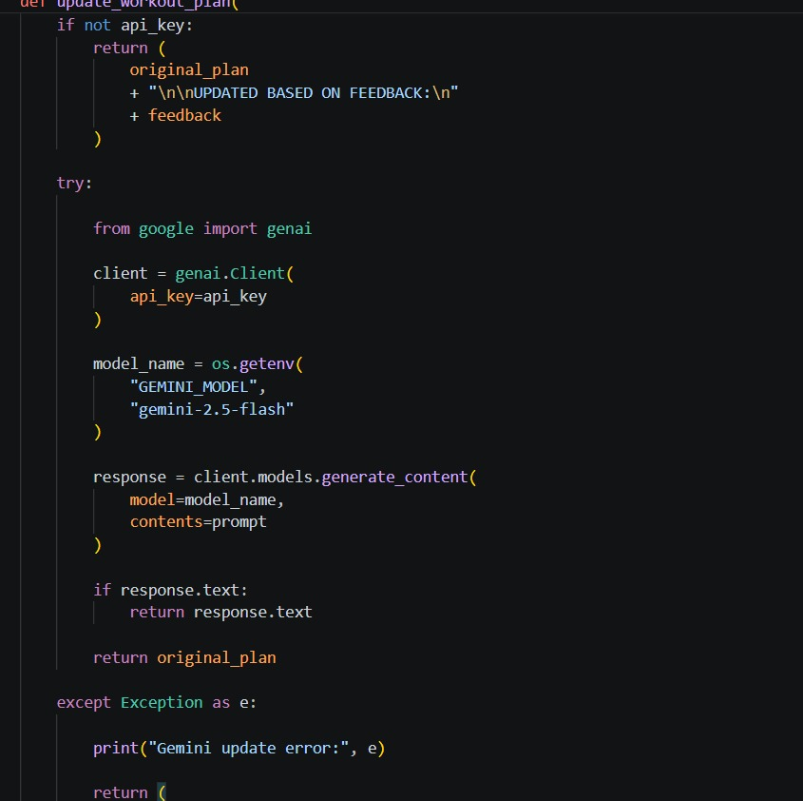
User & Plan Storage
FitBuddy stores user information and AI-generated workout plans in a SQLite database using SQLAlchemy ORM. This allows the application to preserve user details, original workout plans, updated plans, and nutrition tips for later access.
Functions:
save_user() – Stores or updates user information.
save_plan() – Stores the generated workout plan and nutrition tip.
get_user() – Retrieves user details using User ID.
get_original_plan() – Retrieves the original workout plan.
update_plan() – Stores the updated workout plan after feedback.
get_all_users() – Retrieves all registered users.
get_all_plans() – Retrieves all stored workout plans.

File: database.py

The User table stores:
User ID
Username
Age
Weight
Fitness Goal
Workout Intensity

The WorkoutPlan table stores:
Plan ID
User ID
Original Workout Plan
Updated Workout Plan
Nutrition / Recovery Tip

Milestone 3 – Backend Development:

Activity 3.1 – FastAPI Application:

The main application is created in:
main.py

The FastAPI application is initialized using:

app = FastAPI(
title="FitBuddy - AI Fitness Plan Generator"
)

Static files are mounted using:

app.mount(
"/static",
StaticFiles(directory="static"),
name="static"
)

Static files are mounted using:

app.mount(
"/static",
StaticFiles(directory="static"),
name="static"
)

The project routes are connected using:

app.include_router(router)

A health-check endpoint is also provided:

@app.get("/health")
async def health():

return {
"status": "ok"
}
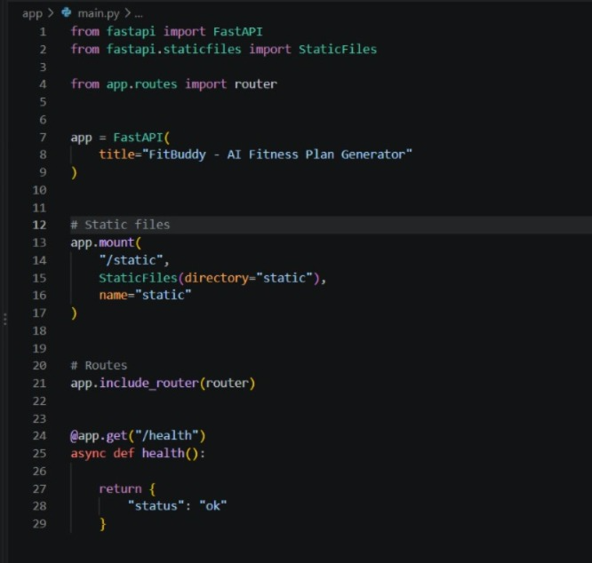

Activity 3.2 – Application Routes:
The application contains the following major routes.

Home Route:
GET /

Displays the main index.html page.
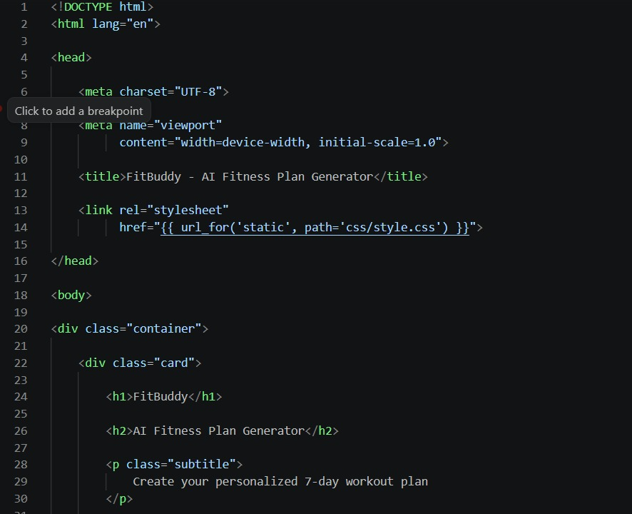

Generate Workout Route:

POST /generate-workout
This route:
- Receives user information.
- Generates workout plan.
- Generates nutrition tip.
- Saves user information.
- Saves workout plan.
6.Displays the result page.

Feedback Route:
POST /submit-feedback
This route:
- Receives User ID and feedback.
- Retrieves the user.
- Retrieves the original plan.
- Sends the plan and feedback to Gemini.
- Generates an updated plan.
- Saves the updated plan.
- Displays the updated result.

View All Users Route:
GET /view-all-users
Displays all stored users and their workout plans.

Main Backend Code:
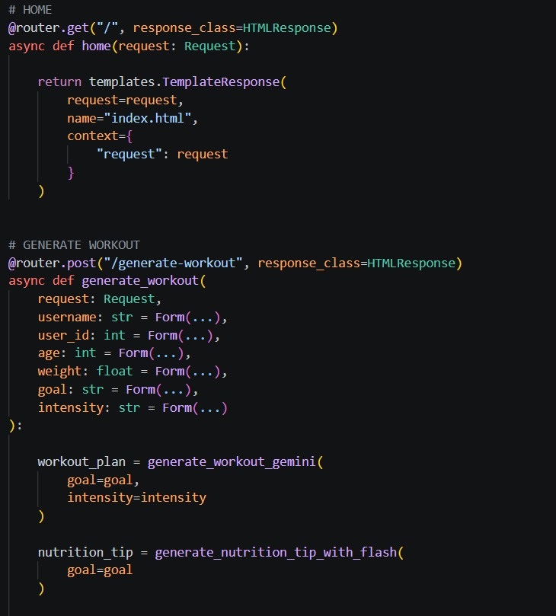
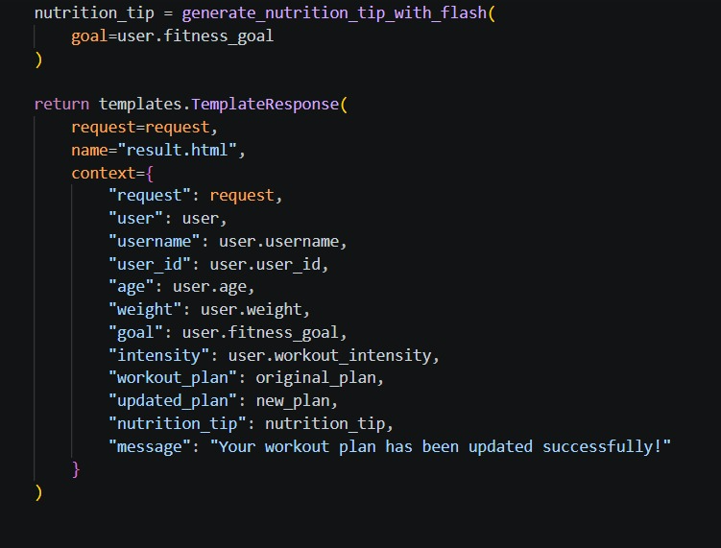
Milestone 4 – Database Development:
The database is implemented using:
- SQLite
- SQLAlchemy ORM
Database URL:
DATABASE_URL = "sqlite:///./fitbuddy_clean.db"

User Table
The User table contains:
User_id
username
age
weight
fitness_goal
workout_intensity
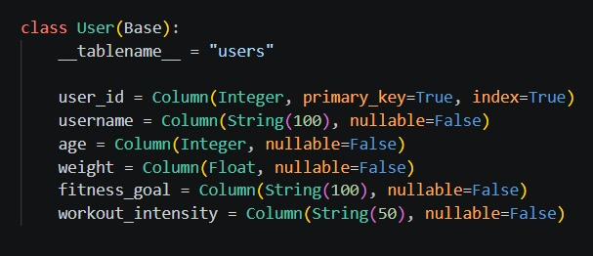

Workout Plan Table:
The WorkoutPlan table stores the generated plans.
Fields include:
id
user_id
original_plan
updated_plan
nutrition_tip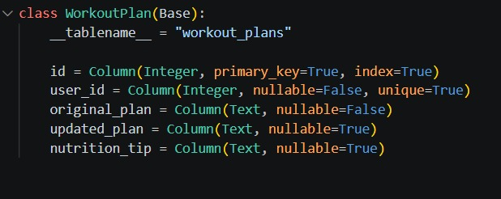

Database Operations:
The application provides functions for:
save_user()
get_user()
save_plan()
get_original_plan()
update_plan()
get_all_users()
get_all_plans()
These functions allow the application to create, retrieve and update user and workout information.

Milestone 5 – Frontend Development:
The frontend consists of three main Jinja2 templates:
index.html
result.html
all_users.html

Activity 5.1 – Home Page:
The index.html page allows the user to enter:
- Name
- User ID
- Age
- Weight
- Fitness Goal
- Workout Intensity
The available fitness goals are:
General Fitness
Weight Loss
Muscle Gain
Flexibility
Endurance
The available workout intensities are:
Low
Moderate
High
The user clicks:
Generate Plan
to generate the personalized plan.

Activity 5.2 – Result Page:
The result.html page displays:

User Information:
- Name
- User ID
- Age
- Weight
- Fitness Goal
- Workout Intensity

7-Day Workout Plan:
The generated AI workout plan is displayed using a <pre> element.

Nutrition / Recovery Tip:
The AI-generated nutrition tip is displayed below the workout plan.

Feedback Section:
The user can enter feedback and click:
Update Workout Plan

Activity 5.3 – All Users Page:
The all_users.html page displays all registered users.
For each user, the page displays:
- User information
- Original workout plan
- Updated workout plan
- Nutrition tip
Jinja2 loops are used to display multiple users dynamically.
Example:
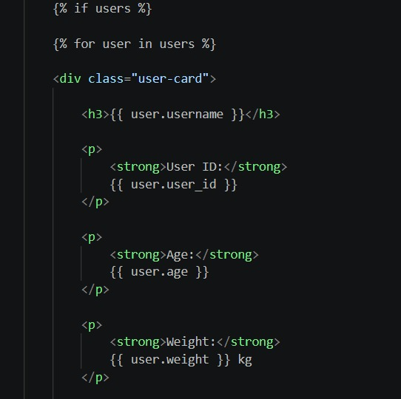
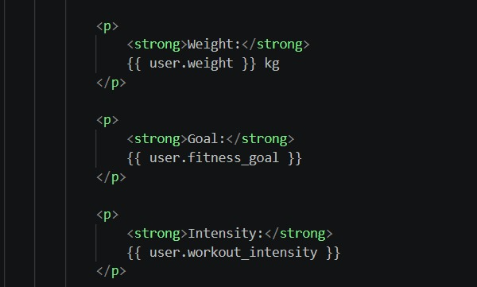

Activity 5.4 – CSS Design
The project uses:
static/css/style.css
The CSS provides:
- Responsive layout
- Centered cards
- Rounded corners
- Buttons
- Input styling
- Result sections
- Success messages
- Error messages
- Mobile responsiveness
The application uses Flexbox for the main layout.

A media query is included for smaller screens:
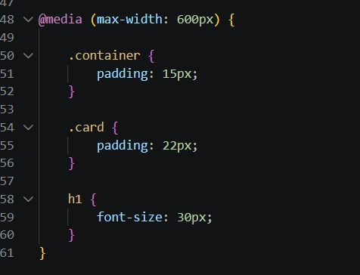

Milestone 6 – Deployment:

Activity 6.1 – Environment Variable:
The Gemini API key is stored using an environment variable:
GOOGLE_API_KEY
The application reads the key using:
api_key = os.getenv("GOOGLE_API_KEY")
The model can also be configured using:
GEMINI_MODEL

Activity 6.2 – Run the Application:
Start the FastAPI server using:
uvicorn app.main:app --reload
The application can then be accessed locally through:
http://127.0.0.1:8000
FastAPI documentation is available at:
http://127.0.0.1:8000/docs

Website Pages:

Home Page:
The home page provides the main FitBuddy form where users enter their personal and fitness details.
The page contains:
- FitBuddy title
- AI Fitness Plan Generator heading
- User input fields
- Fitness goal selection
- Workout intensity selection
- Generate Plan button
- View All Users link
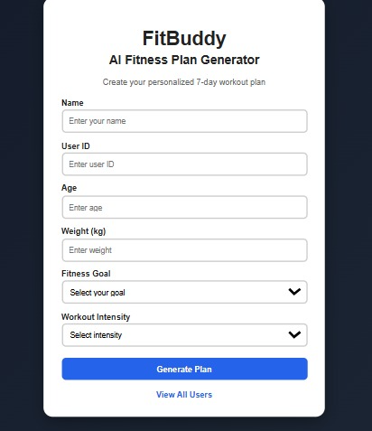

Personalized Workout Page:
After submitting the form, the application displays the user's information and generated 7-day workout plan.
The page also contains the nutrition/recovery tip and feedback section.
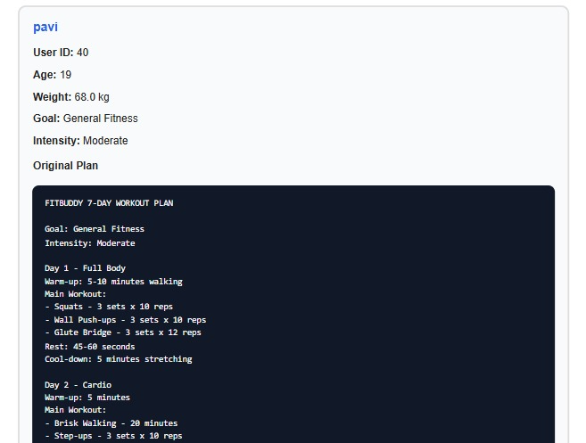
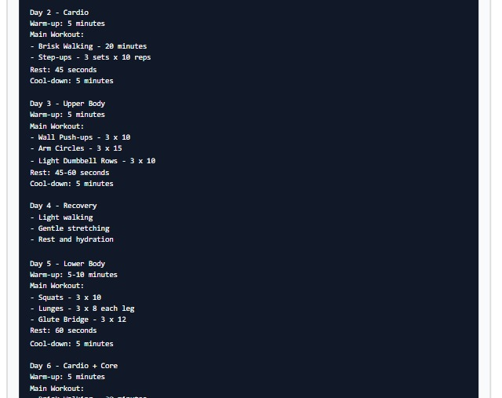
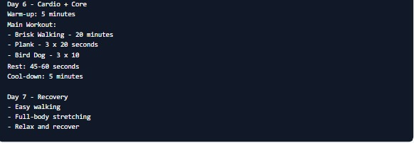
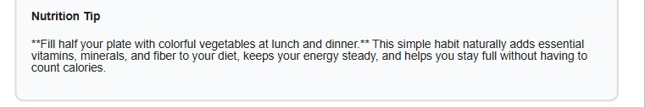

Feedback Update Page:

Users can submit feedback about their existing workout plan.The system processes the feedback through Gemini and displays the updated workout plan along with a confirmation message.
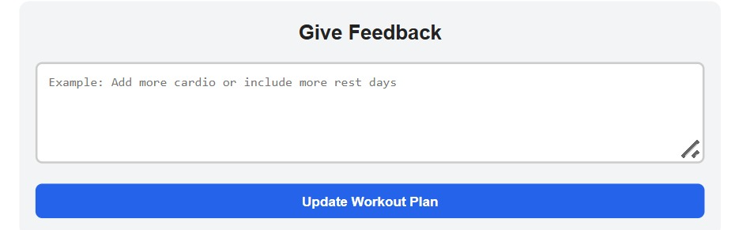
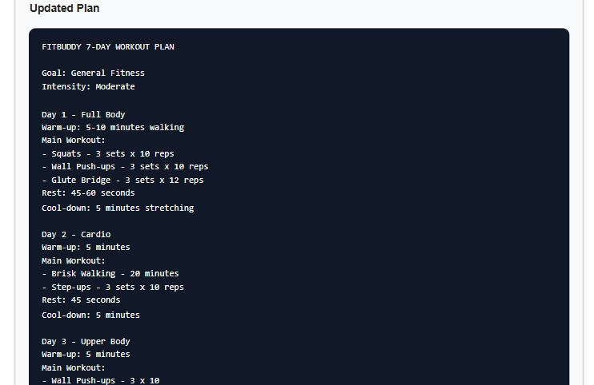
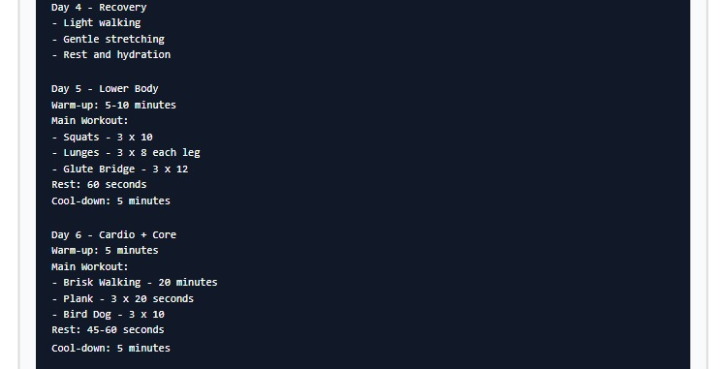
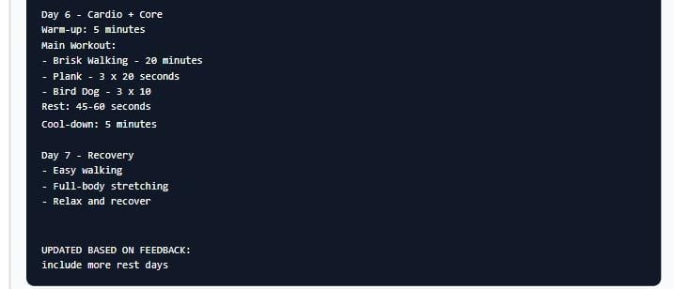

All Users Page:
The All Users page displays the stored user information and corresponding workout plans.
It helps administrators view the original and updated plans for each user.

Conclusion:
FitBuddy is an AI-powered web application designed to generate personalized fitness plans using Google Gemini models. The application accepts user information such as age, weight, fitness goal, and workout intensity and generates a structured 7-day workout plan.
The system also provides nutrition or recovery tips and allows users to submit feedback to update their workout plans. FastAPI is used for backend routing and application logic, while HTML, CSS, and Jinja2 provide the frontend interface.
SQLite and SQLAlchemy are used for storing user information and workout plans. The modular structure of the application makes it easier to maintain and extend the project.
Overall, the FitBuddy project demonstrates the integration of Artificial Intelligence, FastAPI, Gemini API, database management, and web technologies into a single fitness planning application.

